**Title of Your OHDSI Symposium Brief Report Submission**

**Please list all authors and their affiliations in the correct order**

**<1st author name>, <2nd author name>, <3rd author name>   
 1st author affiliation, 2nd author affiliation, 3rd author affiliation**

**Background**

This template should be used as a starting point for the submission. It should be a background of your understanding of the current state of the literature / science as it relates to the topic you are spotlighting in this brief report. This report should be on something that is unpublished in the literature. If you have a preprint on the topic and it is still not accepted in a peer-reviewed publication, we welcome the content for submission as well. Make sure to include a few citations in here of other people’s work. This is a good place to explain why the problem you are solving is relevant to the OHDSI community, and what analytic use case you are aiming to address. This sentence has two reference citations.1, 2

**Methods**

This section should talk about the methods supporting your brief submission. Methods can be interpreted as a new statistical modeling approach, or it can also be the reproducible, repeatable process you followed to generate the brief report content you are writing about. Methods can be a location to describe how databases and populations were selected to ensure inclusiveness and generalizability, when applicable. If you are submitting a report about a software package, methods can include a description of the software design, such as its inputs, functions, outputs, testing, database management systems supported, license, and link to the source code (e.g. Github). Please describe your data source, if there is one.

**Results**

Results should include output generated from the methods. If the submission describes a software package, results can include screenshots of the user interface or analytic output as a result of executing the software. More text of an additional paragraph, with a figure reference (Figure 1) and a figure inside a Word text box below. Figures need to be placed as close to the corresponding text as possible and not extend beyond one page. Use a minimum of 9pt font for Figure captions. You can include up to 3 tables or figures in your submission (these are optional though encouraged).

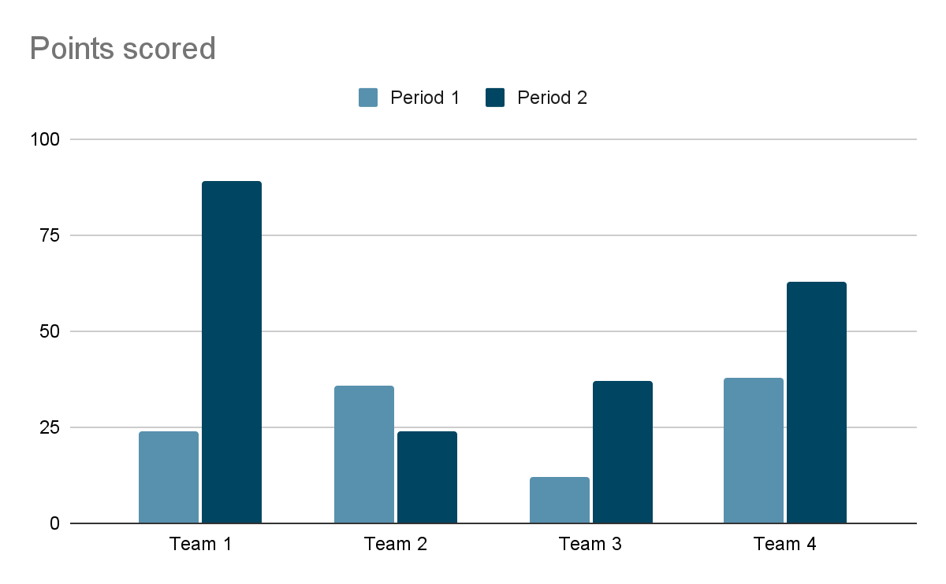

**Figure 1. Points scored by team and period**

The word limit on OHDSI submissions is 1000 words, not including title, authors, affiliations, tables/figures or references (only the text from the start of Background to the end of Conclusions).

**Conclusion**

Your conclusion goes at the end, followed by References, which we suggest can follow the Vancouver Style (see: www.icmje.org/index.html). References begin below with a header that is centered. Only the first word of an article title is capitalized in the References. References do not count towards the 1000 word limit, and may run into another page, if necessary. Conclusion is a good place to state what you expect the OHDSI community to take away from your report.

**References**

1. Pryor TA, Gardner RM, Clayton RD, Warner HR. The HELP system. J Med Sys. 1983;7:87-101.
2. Gardner RM, Golubjatnikov OK, Laub RM, Jacobson JT, Evans RS. Computer-critiqued blood ordering using the HELP system. Comput Biomed Res 1990;23:514-28.